Understanding Charge Density Waves in 1T – TaS2 using Scanning Tunneling Microscopy

Trang Hoang

Sponsored by: Professor Michael Boyer

### **Abstract**

For this project, I analyzed scanning tunneling microscopy (STM) data to understand the electronic properties in the material 1T-TaS2. TaS2 is a material that hosts charge density waves (CDWs). A CDW is a modulation in an electron density within a metal and is accompanied by a periodic lattice distortion and an electronic gap. STM is a reliable tool to observe the atomic structure of a material and how charges arrange themselves. Scientists still do not understand CDW properties on an atomic scale. Studying CDW states above and below their transition temperature will give us an insight into CDW formation and properties.

### **Introduction**

#### **Background in STM**

STM is a technique that uses tunneling electrons to produce real-space images and deliver spectroscopic analysis of the surface material at an atomic level. With this technique, scientists can further understand the atomic structure and bonding in solids at unprecedented levels. For this research, STM has helped in

understanding the CDW of 1T-TaS2 near the commensurate/ incommensurate phase transition [1] [6].

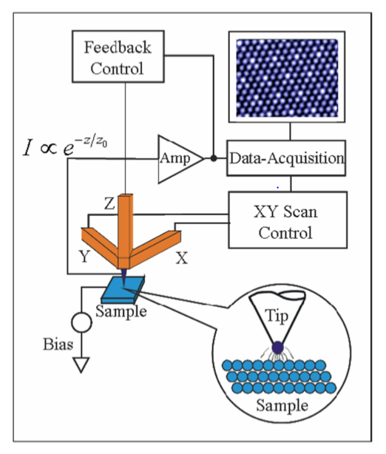

Figure 1: STM schematic with basic components [8]

##### **How does STM operate?**

On a simple note, the STM operates uses a very sharp metal tip to scan the material's surface. The STM consists of a tip, a piezoelectric scanner, current amplifier and a feedback loop. The scanner helps to control the position of the scanner in x, y, z direction. The z - direction of the tip is the distance between that tip and the surface to be measured. The tip-sample distance affects significantly to the tunneling current flow between the tip and measured surface two; the current change of around 1 Ȧ results in a change to an order of magnitude of (x) in the tunneling current. The tunneling current for electron states of energy $ϵ$ is given below:

$$I_{tip→Sample }=-2e\frac{2π}{ℏ}{\left|M\right|}^{2}ρ_{s}\left(ϵ\right).\left[1-f\left(ϵ\right)\right]ρ_{t}\left(ϵ+eV\right).f(ϵ+eV)$$

${\left|M\right|}^{2}$ is the tunneling matrix element $∝ e^{-\frac{z}{z_{0}}}, f\left(ϵ\right)=\frac{1}{1+e^{\frac{ϵ}{k_{B}T}}}$ is the Fermi distribution, $ρ_{s}\left(ϵ\right).\left[1-f\left(ϵ\right)\right]$ is the empty sample DOS and $ρ_{t}\left(ϵ+eV\right).f\left(ϵ+eV\right)$ is the filled tip DOS. After summing all the energy states (using the integral), the tunneling current becomes

$$I_{tip→Sample }=-\frac{4eπ}{ℏ}\int_{-ϵ_{F}}^{∞}{{\left|M\right|}^{2}ρ_{s}\left(ϵ\right).\left[1-f\left(ϵ\right)\right]ρ_{t}\left(ϵ+eV\right).f(ϵ+eV)dϵ}$$

The above equation can be simplify if the measurements are at ~ 0 K. At low temperature, the approximation for Fermi becomes a step function. The integral is then break into 3 parts, as you can see in figure 2b), (1) from $0<ε$, (2) from $-eV< ε<0,$ and (3) from $ε< -eV$. Because we only care about calculating the tunneling current from the tip to the sample, it’s best to integrate only at the (2) part, from $-eV< ε<0,$. If the material of the tip has a flat DOS, $ρ_{t}\left(ϵ+eV\right)$ becomes constant, so the equation can be reduced as follows:

$$I_{tip→Sample }=-\frac{4eπ}{ℏ}ρ_{t}(0)\int_{-eV}^{0}{{\left|M\right|}^{2}ρ_s\left(ϵ\right)dϵ}$$

The tunneling current depends on the tip-sample separation ( ${\left|M\right|}^{2})$ and the sample DOS. This means STM is highly sensitive when there is a slight change in the distance between tip and sample’s surface. [10] As the electrons approach a barrier potential (-eV). The wavefunction outside the barrier has a general solution $ψ=Ae^{ikx}$ in which A is a constant, k is calculated by $E_{f}$ and $-eV$. The current depends on the probability of finding the electrons tunneling, which is ${|ψ}^{2}|=A^{2}e^{2ikx}$. Therefore, the tunneling current is exponentially sensitive to the distance. By applying voltages between the sample and the tip, electrons can tunnel (or "move") from sample to tip or vice versa. The distance between the sample and the tip influences the tunneling current, causing differing current values as the tip scans the surface. The recorded tunneling current values will then go through data acquisition and process an image of atomic resolution. The atomic resolution image that we would work most with in this research is 1T- TaS2 surface topography

#### **Tunneling**

Tunneling is a quantum mechanical effect. A tunneling current occurs when electrons move through a barrier that is classically unreasonable. The barrier in an STM case is the air barrier, the slight difference between the tip and the sample. In traditional physics, electrons are treated like a physical particle, they don't have enough energy to "move over" (go through) the barrier. However, in quantum mechanics, because electrons have wave properties, the wave function extends through the barrier. The wavefunction modulus squared is related to probability density. This means that if the barrier is thin enough, there is a non-zero probability to find electrons cross the barrier; electrons can move through the air barrier from tip to surface or vice versa; this process is called tunneling.

When would tunneling happen? In STM, it is when the voltage bias is applied between the tip and surface. At T=0 K, the energy levels of electrons are filled up to a threshold energy called Fermi energy. The Fermi energy level of the tip is the same as the one of the sample (at which there is no voltage applied). A positive voltage is applied to create a bias between tip and sample. This lowers the energy of the sample by -eV. Doing so would allow electrons to tunnel from filled states to empty states

.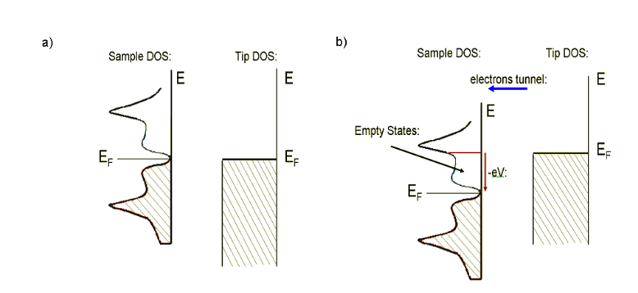

Figure 2: a) No bias voltage difference between the tip and the sample when Fermi energy levels are aligned, so no electron can travel from one side to the other. b) A positive bias is applied to sample, the energy of the sample is lowered. Electrons will travel from the tip filled states to the empty sample states [8]

#### **Background in CDW**

CDW is a modulation of the conduction of electron density in a metal and an associated modulation of the lattice atom position. These modulations show an interesting property of low - dimensional lattice metals. CDW occurs most easily with quasi one dimensional material because of the limited travel paths. In 3 dimensions, electrons have the ability to avoid interaction with other electrons by simply moving in a different axis. But if they are limited to traveling along a chain of atoms, electrons are forced to interact. Moreover, CDW occurs easily with one – dimension materials because the Fermi surface may be conducive for CDW formation. CDW state occurs when there is an opening energy gap in DOS. The energy gap is open due to the lattice distortion. That energy gap is also a way to help explain superconductivity. It is often observed that the CDW state coexists with the superconductivity state. However, the understanding of the relationship between CDW and superconductivity and the formation of CDW is not fully comprehended. The formation of the CDW state within the material can be explained by Fermi-surface nesting, another name is Peierls instability [2,3] and can also be explained by electron-phonon coupling [4].

##### **How does Fermi Surface Nesting form CDW?**

In a quasi-one-dimensional metal, its total electronic energy can be lowered if an energy gap open is at |kF |, kF being a Fermi wavevector. The electron states that have the energy less than EF, Fermi energy, and wave vectors less than |kF| are located inside the Fermi surface. The electron states that do not meet the conditions, outside the Fermi surface, will be empty. As the electrons are filled up with Fermi energy, the electrons are relocated and form a new periodicity. This new periodicity, kF, opens the energy gap. Consequently, it lowers the total energy of the system.

## **Charge Density Waves states in 1T- TaS2**

### **Background in 1T - TaS2**

The material that I am working with for this research, TaS2, supports a CDW and has several CDW transitions slightly above room temperature, which are Nearly Commensurate (NC) and Incommensurate (IC) transition at ~355 K [1]. The material’s CDW transition can be observed easily because of the accessible temperature. By studying TaS2 through the CDW transition phase, we can obtain more information about atomic scale changes in structure and properties of CDWs. 1T- TaS2 is the material of interest because unlike other materials, which domains are readily observable (~ 300Ȧ) such as 2H-TaSe2, its produced a much smaller expected domain (~70Ȧ) [1]

* Basic structure of the material

Figure 3: Crystal structure of 1T-TaS2. The hexagonal unit-cell is represented in red. Adapted from ”. “Watching the birth of a charge density wave order: diffraction study on nanometer-and picosecond-scales”. [9]

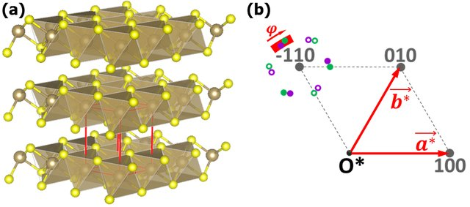

 : Ta atoms

 : S atoms

: Hexagonal unit-cell

1T- TaS2 consists of sandwiches layers of S-Ta-S sheets in which Ta atom is octahedrally coordinated by six S atoms. Within each sheet, the atoms are covalently bonded, while the bonds between the sheets are van der Waals bonds

### **1T-TaS2 CDW phases throughout the temperature range 360K-143K**

From table 1, at a high temperature above 543K, the material is pure metal with no CDW formation. During the temperature that 1T- TaS2 is stable (T < 543K), the CDW maxima (fig 4) is a constructive interference causing from the 3 CDW standing waves which oriented at 120º C. From 543K to 353K, the material changes to an incommensurate phase (called the I phase). In the I phase, the CDW wave vector is perfectly aligned with the lattice wave vector, which cause the angle difference to be 0. In this phase, CDW a wavelength of ${3.53a}_{o}$, $a_{o }= 3.36 A$ = 3.36 unit. The CDW formation can be visualized by a six-pointed “star-of-David” cluster of 13 Ta atoms, shown in figure 4. In this figure, the CDW supercell is rotated 13.9° from the lattice unit cell. The dimension of this commensurate superlattice is

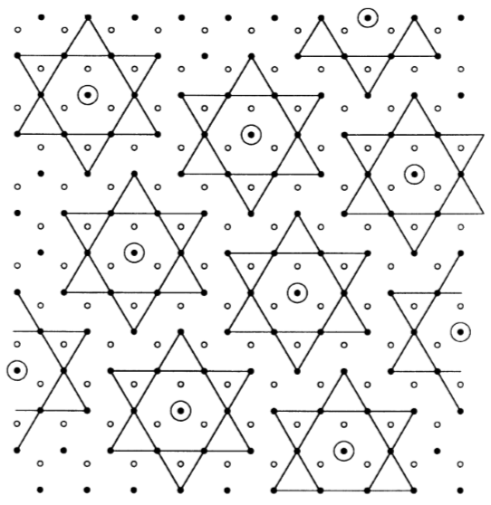

: CDW max formed by constructive interference of 3 CDW’s oriented at 120° relative to each other

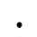: Ta atoms

 : S atoms

Figure 4: CDW formation: blue lines show the CDW supercell; black lines formed “stars of David” whose center is CDW maxima.

The CDW phase changes to nearly commensurate phase (NC Phase) when the material’s temperature is below 353K. The angles difference between the CDW and atomic lattice in NC Phase has a range from 11 - 13°. When the temperature is below 183K, the angle between the CDW and lattice peaks is 13.9º. An angle of 13.9º indicates the CDW is fully commensurate with the lattice underneath[1].. The last phase is called the triclinic phase (T phase). This phase happens when the temperature is in the range from 233K to 283K (during the warming process). In the T phase, the CDW of the material no longer has a hexagonal symmetry structure

a) 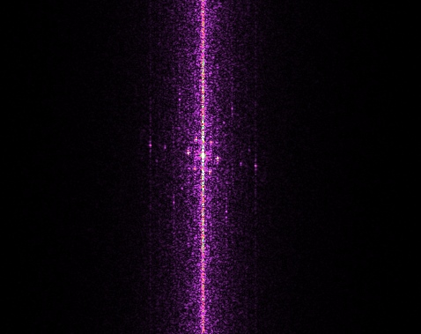 b) 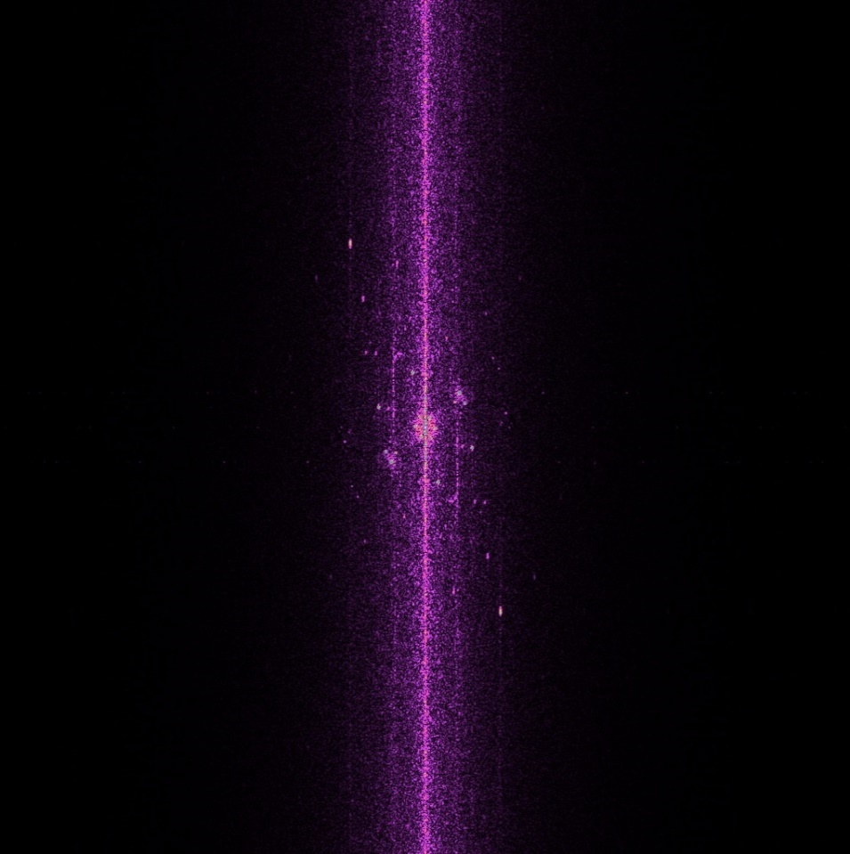

 : Lattice Peaks  : CDW Peaks

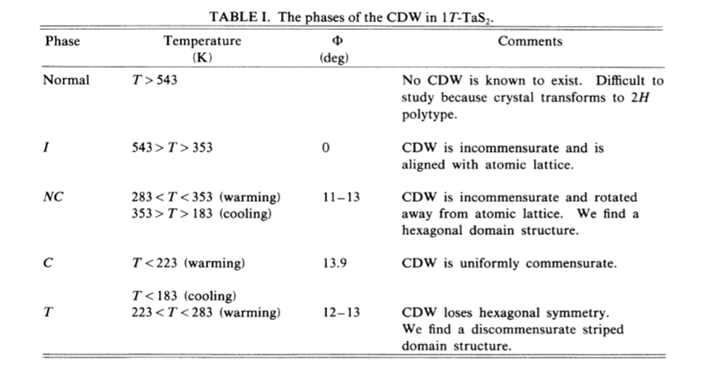

Table 1: The phases of CDW in 1T- TaS2 [1]

Figure 5: An FFT processed image of 1 T-TaS2 in a) incommensurate phase: #1857 at 362.4K - cooling down. The line demonstrate that the lattice and the CDW align. b) nearly commensurate phase: # 2509 at 356.13K – warming up. You can clearly see that the lattice peaks and the CDW peaks are not formed a straight line (these FFT images are not affine corrected) _obtained at our lab

As seen from the above table, the interesting CDW phase transitions, from I phase to NC phase, happens around (or slightly above) the room temperature range. This is a plus point for research because we can easily access that temperature.

### **Experiment Procedure**

The environment of 1T-TaS2 is controlled by a thermal bath. The sample was taking at both warming and cooling point. The warming process starts at room temperature goes to 361 K; then the cooling process starts from around 360K to room temperature. At given a temperature value, the sample’s topography is scanned at different scanning rate, different pixels, range of tunneling conditions (200 to 500 pA, typical settings we use in our measurement) and range of bias voltage (-100 to -500 mV, typical settings we use in our measurement) so as to eliminate holes’ formation and noise in the topography.

* Affine Correction:

Before doing any measurement and in-depth analysis from Fast Fourier Transform (FFT) image, we undergo image affine correction. This method allows us to detect the underneath lattice and most importantly to correct for some scanner hysteresis and drift. The FFT image without the affine correction distorts the hexagonal formation of the CDW, lattice and domain.

a) 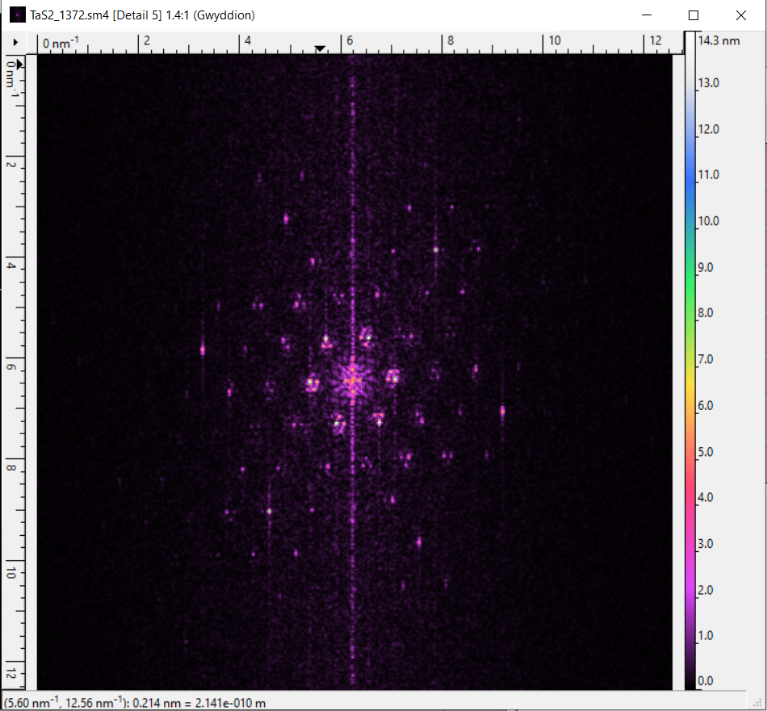 b) 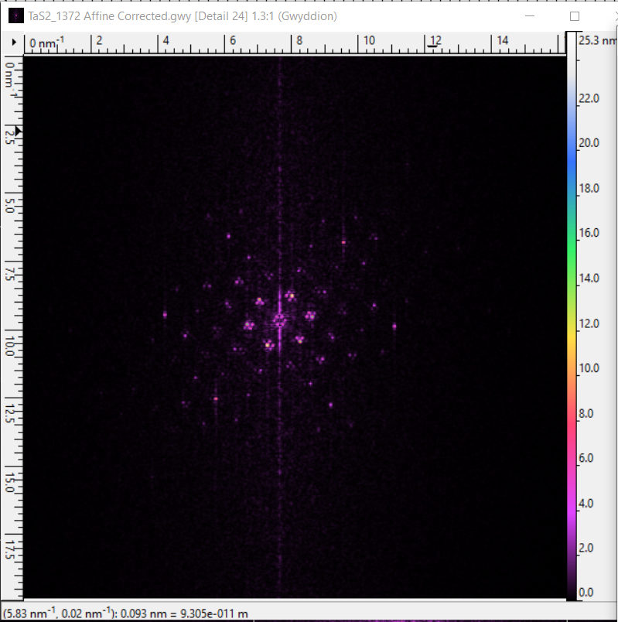

Figure 6: Both of the FFT picture is in 440x440 pixels size: a) Before affine correction, the hexagonal structure looks elongates. b) After affine correction, the domain structure looks hexagonal _ obtained at our lab

To affine correction, we first choose a FFT image that can clearly show full 6 atomic lattice peaks. Then, we only filter those atomic peaks. We would obtain values for lattice vectors. Correcting the lattice involves inputting the lattice vectors previously obtained, adjust the atomic spacing (a1) to 0.336 nm-1 and phase ɸ = 60.0 deg.

The samples are grown at HQ Graphene and then mounted at Professor’s Boyer lab for study. The materials are investigated with temperature dependent measurements. The temperature ranges from 298 – 360 K, which covers the CDW phase transition.

### **Analysis and Result**

#### Angle between atomic lattice and CDW at temperature from 354 K – 360 K

The initial state of my research focuses on familiarizing myself with the analysis tool, Gwydion and comparing CDW wavelength, angle comparison with famous research related with 1T- TaS2 [1][7]. The first hypothesis that we propose relating to the angle between CDW and atomic lattice is near the transition phase (from IC to NC or vice versa) the angle should slowly rotate from 0 deg (IC phase) to 11 – 13 deg (NC Phase). The second hypothesis is that the CDW is fully commensurate in the center of the domain and not commensurate at the edge of the domain; By averaging out the value of the angle difference between atomic lattice and CDW wavevectors, the result would be in a specific range that are lower 13.9°. We start looking for FFT images that have both lattice peaks and CDW peaks. We then measure the angle difference between them using 2 lines (one formed by atomic lattice pair and one formed by CDW pair), Figure 7.

a) 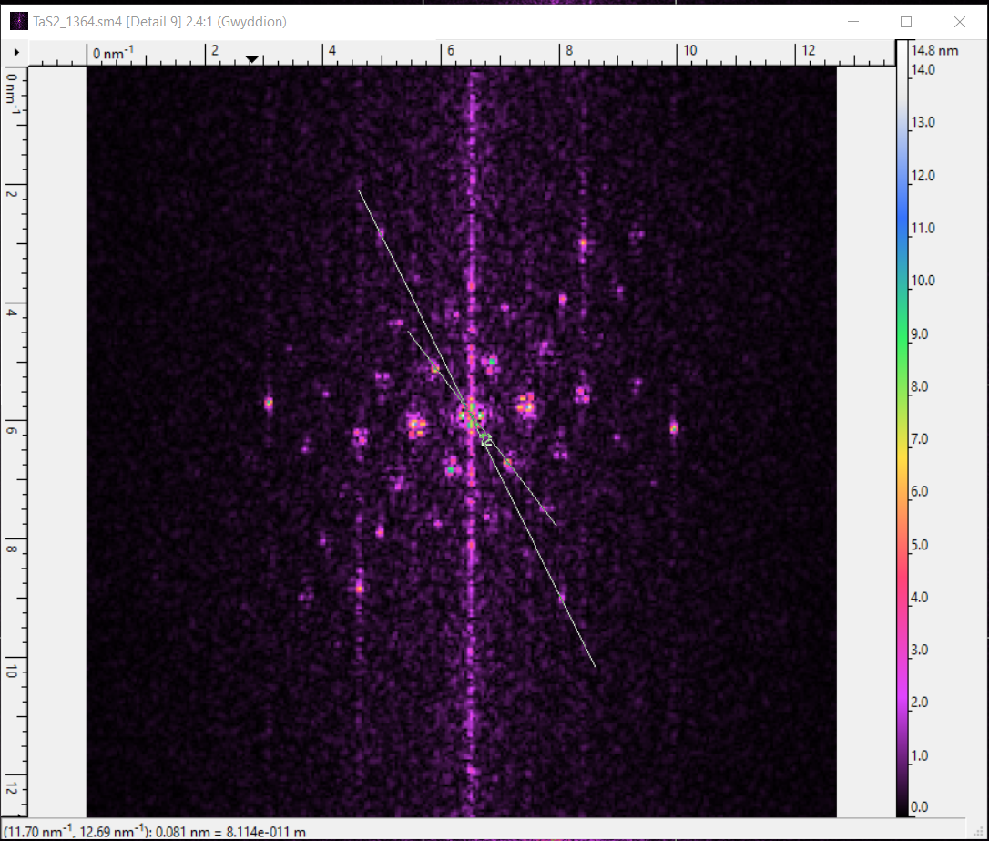 b) 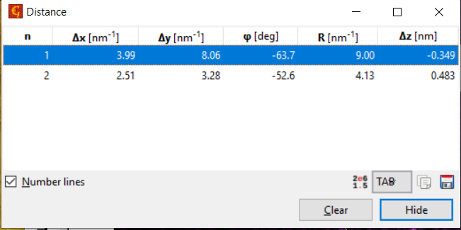

c) 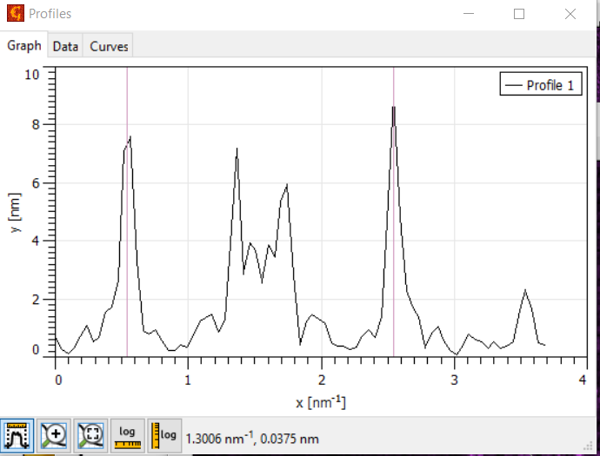

Figure 7: a) FFT image of an NC phase: An angle differences created by 2 lines from lattice peaks and CDW peaks.b) The angle of each line with respect of the x axis. c) The distance between 2 red lines assists determining wavelength of CDW.

Out of around 7000 data set, I obtain 28 data that match with what we need: having both atomic lattice peaks and CDW peaks. (Appendix). We chose the 2 line pairs that are closest to each other to find the difference. Because of the intrinsic nature of the hexagonal structure, we just need to measure one angle value, instead of 3, for each FFT data image. Graphing out the angle values, we notice that the angle difference behaves in a no clear trends manner. This concludes that the angle between CDW and atomic lattice is unbiased with temperature. Pretty close to the value proposed in table 1 for NC phase, the value for the angle between CDW and lattice is $11.60 ° ±1.31$

Figure 8: The angle difference between CDW and atomic lattice against temperature

* In the warming process, the temperature starts at room temperature to 360K, until we see the first IC phase. From the graph, we can tell that the IC phase happens when the temperature is higher than 360K. We have seen NC phase at a temperature that is different thant previous findings. In table 1, it indicates that NC phase happens at $283 K<T<353 K$. I have found a data set that demonstrates NC phase at temperature that is larger than 353K (figure 9). To make sure that the bright peaks are not coming from noise, after correcting, I measure the wavelength between the bright peaks. If the wavelength for lattice is around $3.36\dot{A}$ and for CDW is $11.8\dot{A}$, it is likely that those chosen peaks aren’t noise. The FFT images of those data are illustrated in figure 9.

a) 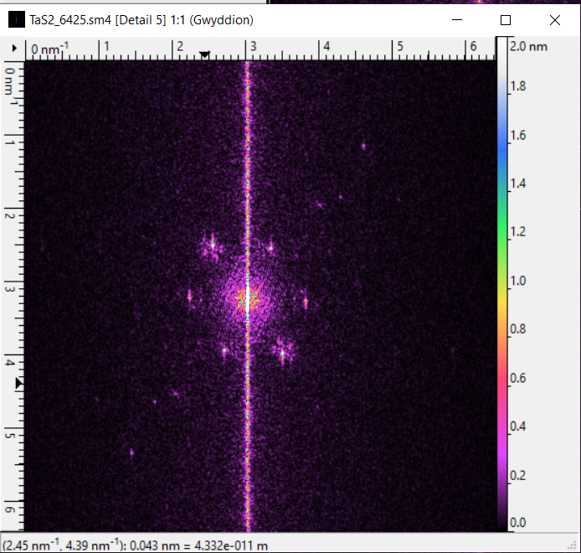 b) 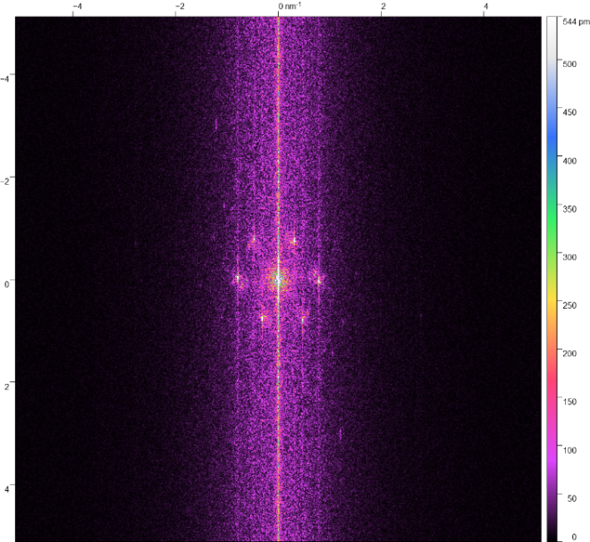

c) 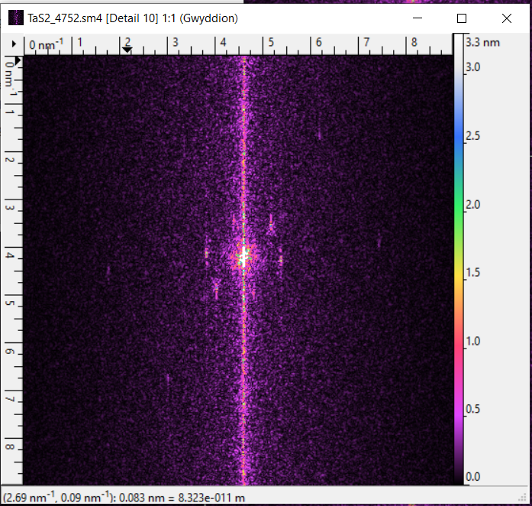 d) 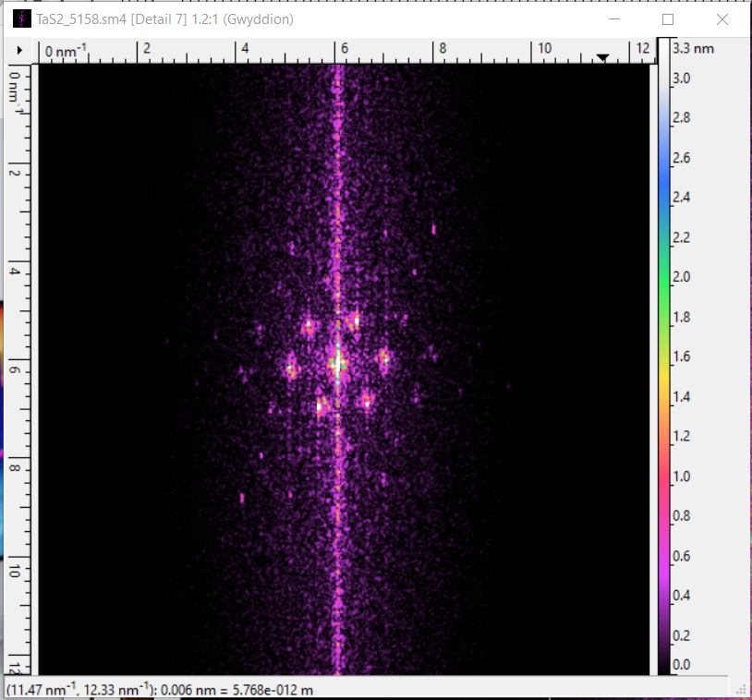

Figure 9: FFT images of 1T – TaS2 in NC phase at: a) 356.1K b) 356.4 K c) 357.2 K d) 359.10 K_ obtained at our lab

#### Angle between CDW + low-Wavevector and angle between low-wavevector + lattice from 354K to 360K

Within the domain, the CDWs are commensurate with the lattice, and between domains the CDW amplitude decreases and the CDW phases change [7]. Up until now, it is unsure of how the domain is formed and what its properties. As the temperature changes, we suspect that the domain might also slowly change its rotation. Because domains form as the material transits from I phase to NC phase, there might be a relationship between them. We test that rate of change through the difference between CDWs and domain to see if there is any relation.

Figure 10: The angle difference between CDW and domain against temperature

The huge gap between 300 – 354K exists because in our lab data, there is no obvious low-wavevector in the FFT image. There are several conclusions from the graphs and from the FFT images: the angle difference shows is unbiased with the temperature due to the random distribution of the data, the low-wavevector formation only preferred at some temperature; and there might only be a clear angle difference between the at 300K and 354K but not within similar temperate range between warming/cooling. To create a more reliable graph, we should try to further investigate to see if there is low-wavevector formation between 300K and 354K. From the data that used to graph figure 10, the material is in NC phase. Moreover, there are significantly less domain appearance in the cooling process. It might come from that low-wavevector formation has a preferred temperature range that happens in the warming process. Or it can be that we lacks of information during the cooling process.

Table 2: A few data relating to domain’s wavelength and angle difference with lattice

|  |  |  |  |
| --- | --- | --- | --- |
|  | Temperature (K) | Wavelength ( $\dot{A} )$ | Angle difference atomic lattice and low-wavevector (deg) |
| #960 | 294.3 | 69.93 | 7 |
| #554 | 294.3 | 72.2 | 6.2 |
| #1372 | 300 | 64.9 | 6 |
| #2959 | 300 | 64.52 | 5.8 |
| #3576 | 354 | 45.45 | 5.5 |
| #2873 | 356.08 | 52.63 | 6.3 |
| #1364 | 358.045 | 55.25 | 4.9 |

While there are changes in the angle between CDW and low-wavevector as temperature changes(figure 10), the angle between atomic lattice and low-wavevector is stay in the range from 5 – 7 ° ($5.96 ±0.436°)$. The wavelength of the low wave-vector is temperature independent with an average of 60 $\dot{A}$. Due to the lack of available data, I could not determine the wavelength and the angle difference at a variety of temperature value.

#### Domains formation and satellite peaks:

We fortunately have the data that have 2nd and 3rd order satellite peaks at room temperature. With the help of filtering, we might have a better understanding of how CDW domains are formed.

1. 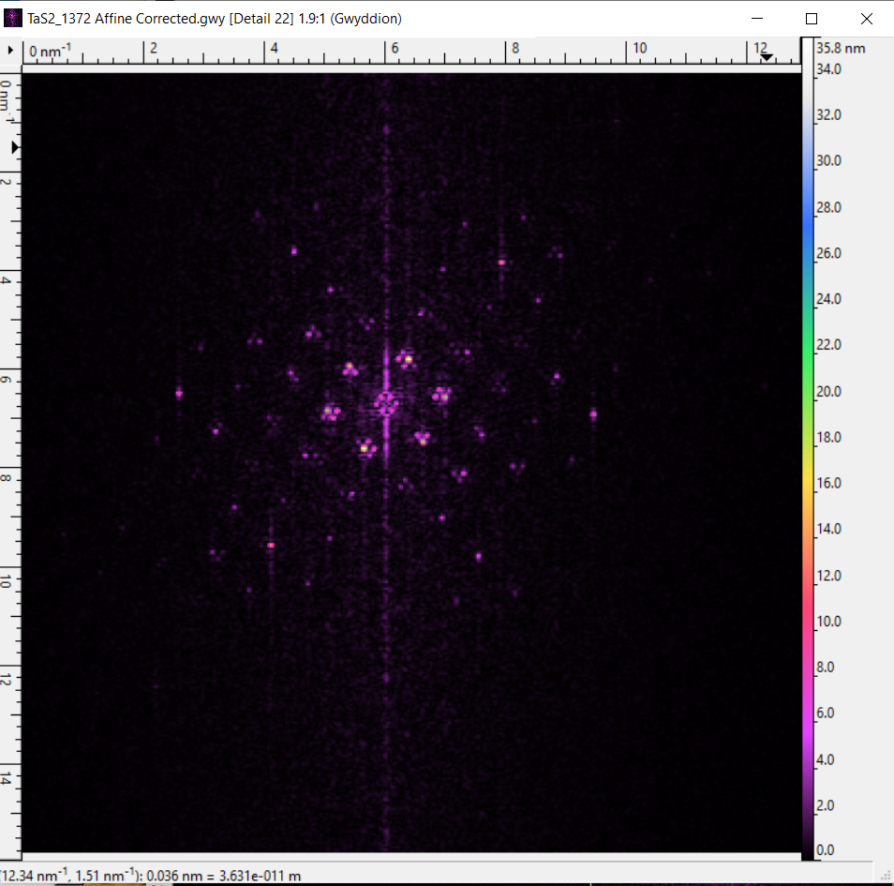 b) 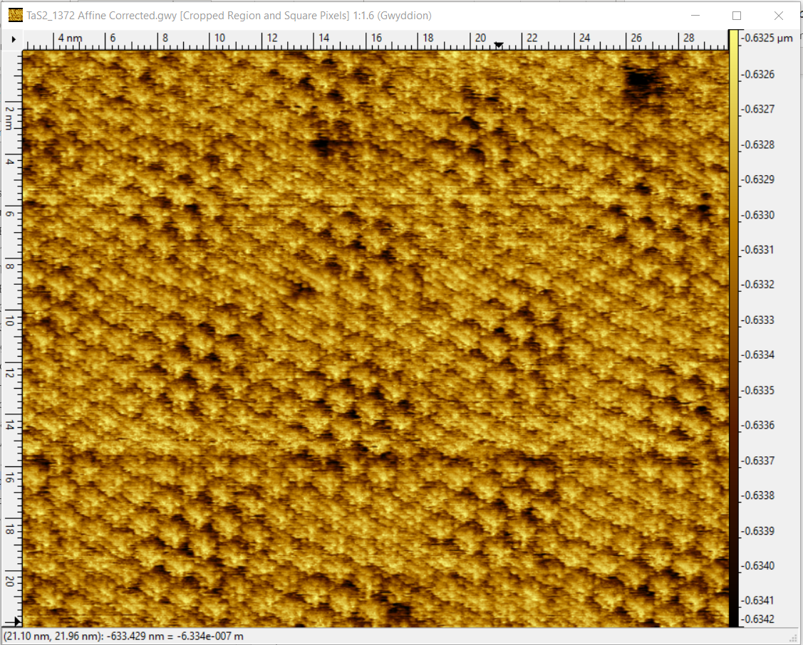

Figure 10: #1372 at 300K. Both pictures obtain from a data that has 2nd and 3rd order satellite peaks along with clear low-wave vector peaks. a) FFT image of image. Inside the open yellow circle, you can see that there exist one brightest peaks _ CDW peaks, and the remaining 2 represents satellite peaks. In the green open circle, there is a hexagon shape with 6 peaks; those peaks represents low-wavevector peaks b) this topography shows several clear domains. One is illustrated through a red circle _ obtained at our lab

To study the domain formation, I first filter out the lattice and the CDW peaks (without selecting satellite peaks). The result gives me fully commensurate CDW, CDW aligning with the lattice underneath. (figure 11.a). My next question is that what decide the formation of the domain in the topography, the low-wave vector peaks or the satellite peaks. In figure 11.a), I filter atomic lattice and CDW peaks without the satellite peaks. There are huge shadows at the area where domains exist and there is no CDW formation. Those shadows might create “false” domains in the topography image. What I mean “false” is in the topography, it might show dark region; yet, in the corresponding FFT image, there might not have satellite peaks. On another hand, the existence of the low wavevector help us in roughly determines the domain location. In figure 11.b, I filter lattice peaks and just satellite peaks (without selecting CDW), I can see clearly the domain formation, along with CDW formation. In the center of the red circles (figure 11.b), it looks similar to CDW figuration in figure 11.a). This might be that the inside (or center) the domain, the CDW stays fully commensurate with the lattice underneath. When transitioning from I phase to C phase, the CDW might interact with the underneath lattice in a way that there are sudden shift in CDW periodicity. The shift in domain happens at the domain wall, where CDW from one domain interfere with CDW from adjacent one. The CDWs wave interference causes the formation of satellite peaks. In figure 11.b), remembering that there is no CDW peaks selection (just atomic lattice and satellite peaks), yet, we can still observe some sort of CDW commensurate in the center of each domains. This further proves sudden shifts in the CDW periodicity from one domain to the next creates satellite peaks formation in CDW. This has been proved in Thompson’s thesis [1]

a) 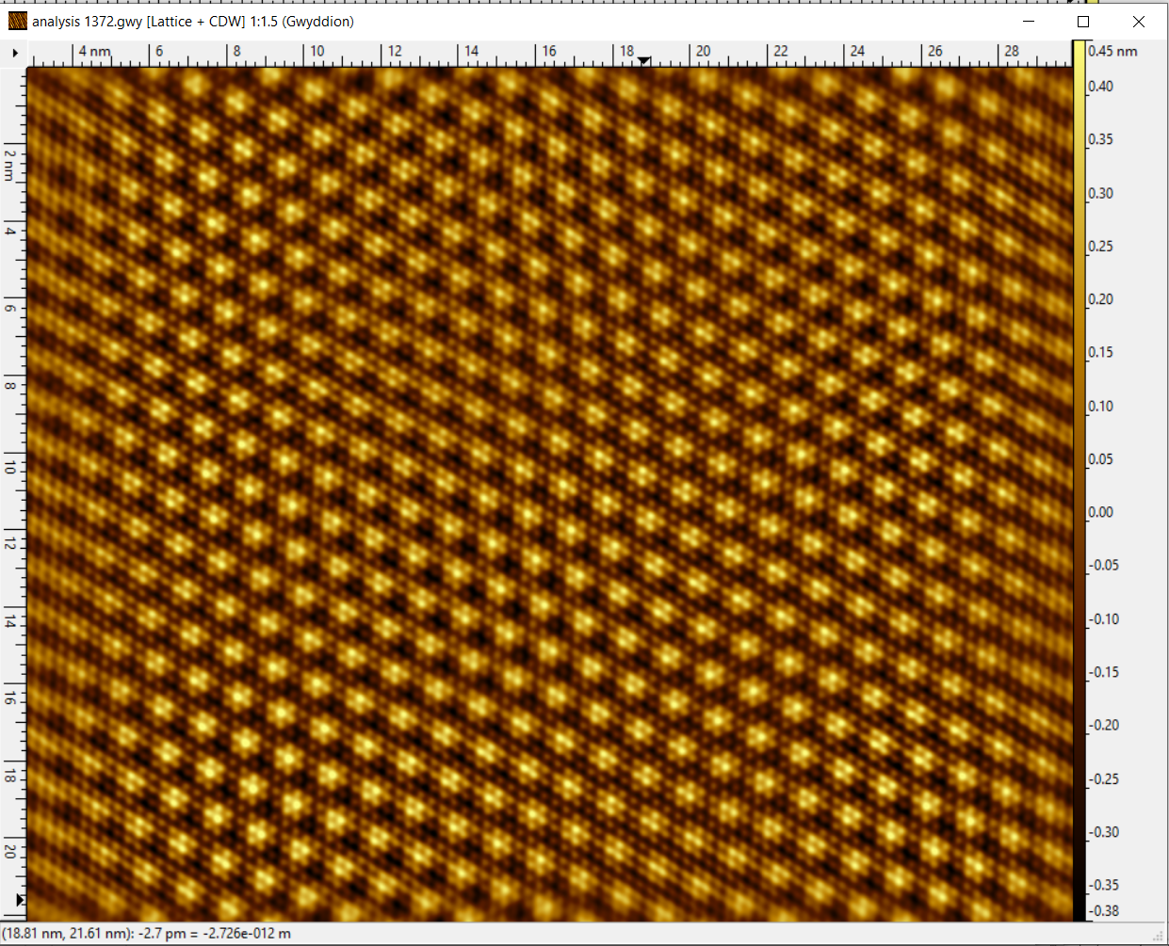

b) 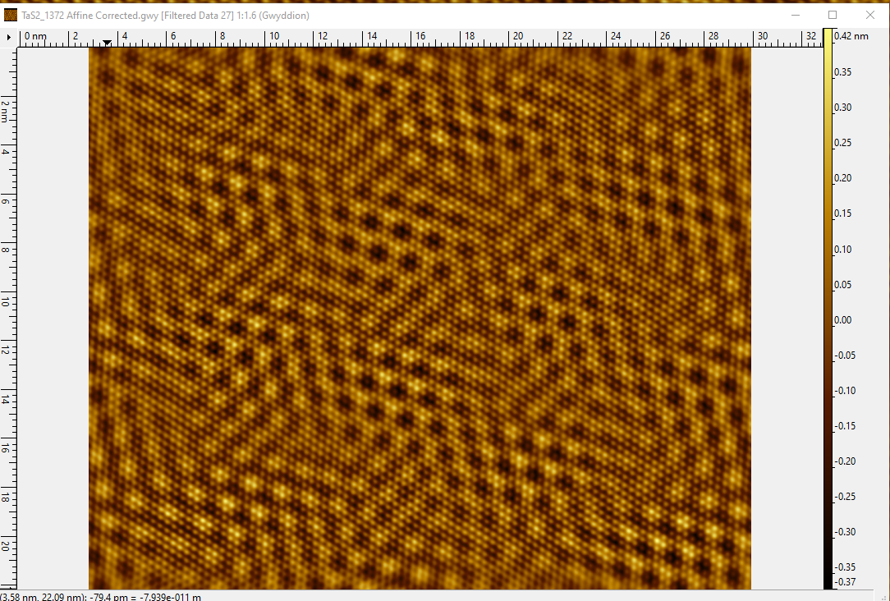 c) 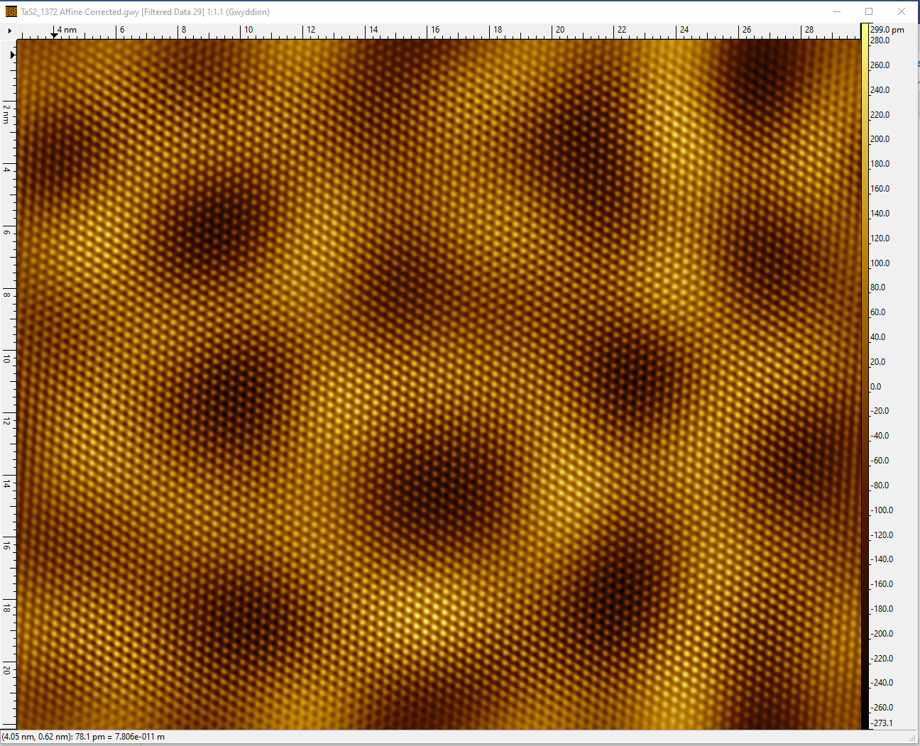

Figure 11: a) Filtering atomic lattice and CDW peaks. b) Filtering atomic lattice and satellite peaks. c) Filtering atomic lattice and low-wavevector peaks

To create figure 12 a) and b) from the center of the domain, I extend the lines until there are no obvious bright peaks that belong to that domain because I want to understand what would happened to CDW as I go from one domain to the next one, especially at the domain walls. With in the region, I select the dots by making sure 2 conditions: the dots are at the vertices and compared them locally, they have to be one of the brightest peaks. Next, I would pick the bright green as the center domain to see how the center domain interacts with the neighboring one. At the edges of the bright green domain, there are some sort of overlapping with other surrounding domains (figure 12a). Each domain might have a different CDW’s wave phase. The interaction of the CDWs that have different wave phases causes some sort of shift. This shift creates the domain walls and the existence of the satellite peaks (figure 11a). As literature has pointed out that, the satellite peaks are good indicators of domaining [1]

a) 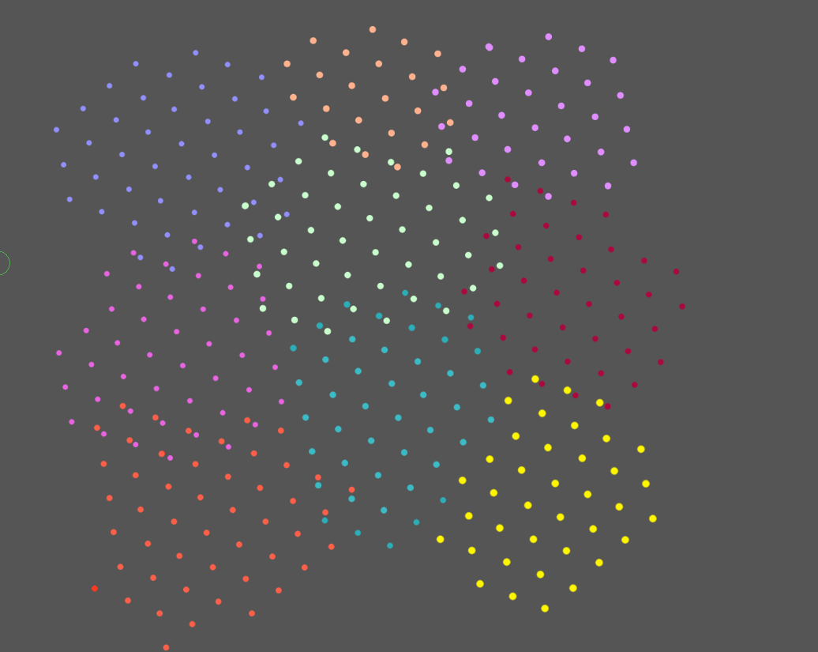 b) 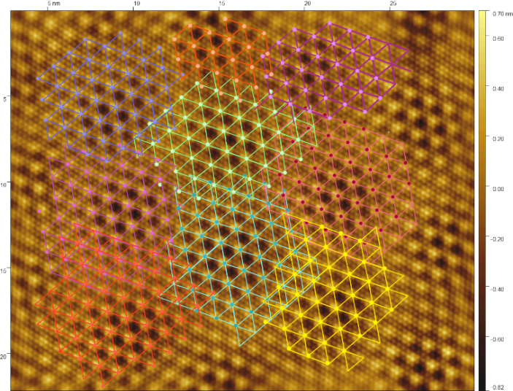

c)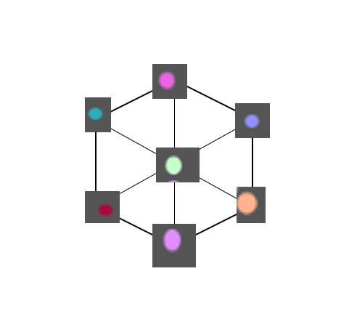

Figure 12 a) The each color dots belongs to the domain that has correspond colors. b) Filtering atomic lattice, CDW, satellite and low-wavevector peaks. Each domain has its own color lines and bright color dots. _obtained at our lab c) Selecting the dots (with the bright green domain dots as the center) and placing it in an hexagon to study phase slip

The bright spots can be seen as the CDW representing for its corresponding color domain. In figure 12c), taking a closer looks at the orange domain. The domain position is at the top of the bright green domain and its corresponding CDW is at the bottom right of the bright green dots. The angle difference between the domain position and the CDW is roughly around 120. Because the position of the domain is fixed, maybe the CDW phase slips from domain bright green to domain orange is around 120°. From the center domain to the surrounding domain, the CDW phase slip is roughly around 120°.

## **Conclusion**

As we have observed in this research, there are several characteristics about the 1 T- TaS2 CDW and domains in the phase transition that we observed in this research: right around the transition temperature range (300 – 354 K), there is no clear trend behavior on how the angle between CDW and the atomic lattice depends on temperature; the CDW’s wavelength in both phases is roughly about $11.8\dot{A}±0.4 \dot{A}$. In the phase transition, there are topography images illustrating the formation of domains. The angle between the domain and the underneath lattice is temperature independent and has a value roughly $5.96 ±0.4°$ (calculating from table 2). The true domain can only form when there are satellite peaks. Moreover, I haven’t been able to find the method to accurately detect low-wavevector beside relying on topography and FFT images. Even though, detecting dark regions from topography also helps determining low-wavevector, it is possible that the topography only has satellite peaks in its FFT image (no low-wavevectors) (figure 13). The detection of low-wavevector and the existence of satellite peaks allows accurately detects domain. Inside of the true domain, the CDW is fully commensurate with the underneath lattice. I think that as the domain going from one domain to the next, there are a CDW phase slip between the 2 domains, which has a value roughly 120°. This alignment would cause each domain to have a different CDW’s wave phase.

When a domain’s CDW interacts with adjacent one, the different in CDW wave phase causes wave interference, which creates domain’s boundary. Our domain formation analysis used only one data set. The study of the domain might be understood better if we have several more data set, in which its FFT has lattice peaks, CDW peaks along with 2nd or 3rd order satellite peaks, and low-wave vector peaks.

a)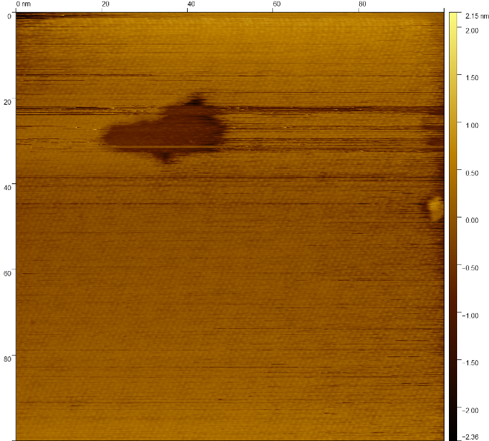b) 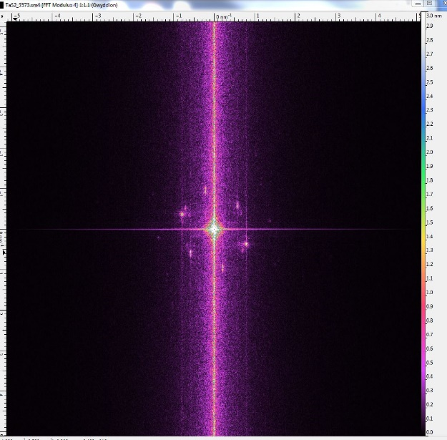

Figure 13: 3571 at 358.19K a) Topography b) FFT image: there is no obvious low wavevector, yet, there are some satellite peaks _ obtained at our lab

## **Reference**

[1] Thomson, R.E, B. Burk, A. Zettl, John Clarke. “Scanning tunneling microscopy of the charge-density-wave structures in 1T-TaS2”

[2] R. E. Peierls, Ann. Phys. Leipzig 4,1

[3] M. D. Johannes and I. I. Mazin. “Fermi surface nesting and the origin of charge density waves in metals”. Phys. Rev. B - Condens. Matter Mater. Phys.,77(16):165135(2008).

[4] .G. Grimvall. “The electron-phonon interaction in metals”. North-Holland Pub. Co.(1981). R. E. Thorne. Charge-Density-Wave Conductors. Physics Today, 1996

[5] R. E Thorne. “Charge-Density-Wave Conductors”. Physics Today, 1996

[6] B. Giambattista, C. G, Slough, W. W. McNairy and R. V. Coleman. “Scanning tunneling microscopy of atoms and charge-density waves in 1T-TaS2, 1T-TaSe2, and 1T-Vse2”. 1989

[7] Xian Liang Wu, and Charles M. Lieber. “Hexagonal Domain – Like Charge Density Wave Phase of TaS2 Determined by Scanning Tunneling Microscopy”. 1989

[8] M. Boyer.Investigating the Relationship Between the Superconducting and PseudogapStates of the High Temperature Superconductor Bi-2201 Using Scanning TunnelingMicroscopy. Ph.D. thesis, MIT (2008).

[9] Claire Laulhe, Tim Huber. G. Lantz et al. “Watching the birth of a charge density wave order: diffraction study on nanometer and picosecond-scales”. 2017

[10] Hoffman Lab. “STM: More Technical details*”.* [*http://hoffman.physics.harvard.edu/research/STMtechnical.php*](http://hoffman.physics.harvard.edu/research/STMtechnical.php)

## **VI. Appendix**

* Table for figure 8:

|  |  |  |  |  |  |
| --- | --- | --- | --- | --- | --- |
| # | Temperature (K) | Angle difference between atomic lattice and CDW (°) |  | | |
| 79 | 294.3 | 13.6 |
| 86 | 294.3 | 11.96667 |
| 93 | 294.3 | 14.43333 |
| 94 | 294.3 | 11.9 |
|  | Warming | | # | Cooling | |
| 2336 | 355.83 | 10.5 | 4375 | 354.8 | 12.5 |
| 2321 | 355.83 | 10.76667 | 4522 | 354.14 | 12.33333 |
| 3163 | 356.08 | 10.7 | 4568 | 354.22 | 11.7 |
| 3238 | 356.6 | 11.5 | 6165 | 356.16 | 9.1 |
| 3439 | 356.94 | 11.83333 | 6243 | 356.11 | 10.9 |
| 3452 | 356.96 | 12.2 |  | | |
| 3489 | 357.39 | 11.25 |
| 3506 | 357.47 | 12.5 |
| 4681 | 356.74 | 11.43333 |
| 4665 | 356.72 | 10.76667 |
| 4743 | 356.74 | 9.8 |
| 4763 | 357.72 | 10.5 |
| 5301 | 359.04 | 11.23333 |
| 5172 | 358.63 | 12.1 |
| 5176 | 358.66 | 11.6 |
| 6432 | 356.36 | 13.2 |
| 6343 | 356.17 | 12.8 |
| 6699 | 356.73 | 11.25 |
| 6755 | 359.28 | 10.4 |